DAP BFF Architecture (Draft v0.1)
Oct 9, 2026 · @Rahul Pandey

Summary
DAP should expose one thin BFF per experience — Ops Console, Approver, BU Desk, Back Office and Client Wallet — each shaping data, sessions and entitlements for its own users, while all of them submit the same signed platform intents and read the same CQRS projections. No BFF holds policy, ledger, chain or signing logic.
This is a companion to the DAP architecture review; it assumes that doc's target state (single PDP, sub-ledger, custody SPI, event backbone).

Why a BFF layer
- Very different consumers. A DAP ops engineer onboarding a shard, a compliance approver on mobile, a WM advisor desk and a back-office reconciler need different payloads, auth flows and latency profiles. One generic API forces every client to over-fetch and re-implement aggregation.
- Keep secrets out of browsers and devices. DAP's x-dap-api-key and message-signing keys must never reach a client. The BFF is the token-exchange and intent-signing boundary for human channels.
- Entitlements by experience. A WM desk must not see ISG positions (Chinese wall). Field-level filtering and masking belong in the BFF, and DAP enforces them again.
- Real-time UX. The tx lifecycle (SIGNED → BROADCAST → FINALIZED) is event-driven; BFFs turn backbone events into SSE or WebSocket pushes per user.
- Independent delivery. Each frontend team ships its BFF on its own cadence without changing DAP core APIs.

Architecture
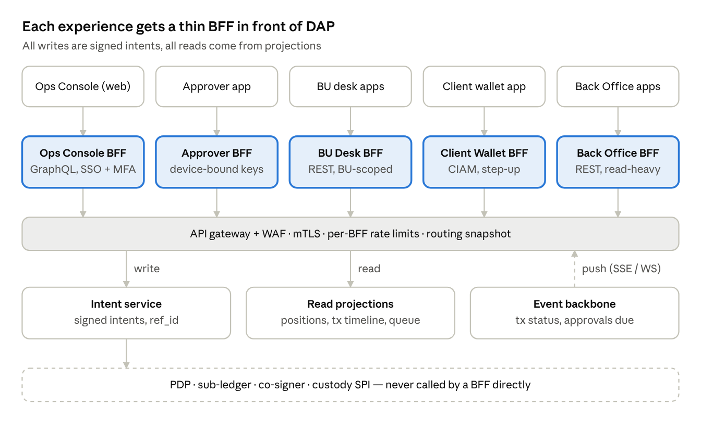
BFF layer · 5 experiences in front of DAP
Each client talks only to its own BFF; BFFs reach DAP through one gateway, write only via the Intent service, read from projections, and receive status pushes from the event backbone. The PDP, sub-ledger, co-signer and custody layer sit behind the Intent service and are never reachable from a BFF.

BFF catalogue
Five BFFs, split by user population and trust level rather than by screen.
BFF | Users / client | Main capabilities | Auth | Special concerns
Ops Console BFF | DAP Ops, BU Ops; web | Tenant onboarding, shard health, policy authoring (PAP), registry views, incident and break-glass tools | Firm SSO (OIDC) + step-up MFA for admin intents | Admin actions as intents; 4-eyes on policy changes; break-glass fully audited
Approver BFF | Quorum approvers; mobile app | Pending approvals, decoded tx view, simulated balance deltas, approve / reject | SSO + device-bound key (Secure Enclave / StrongBox, WebAuthn) | Approval signs the hash of the decoded view (WYSIWYS to the human); push notifications carry no sensitive payload
BU Desk BFF | WM / ISG / IM middle-office apps | Positions, transfers, token actions, settlement status, statements | SSO, BU-scoped roles | Chinese-wall filtering; high read volume served from projections
Client Wallet BFF (future) | WM clients; web + mobile | Holdings, deposit addresses, transfer requests, statements | Client identity (CIAM) + step-up | Strict rate limits, PII minimisation, deposit address rotation
Back Office BFF | BO ops (Books & Records, recon, corporate actions); web | Recon break queues, books & records views, corporate-action and tax views, on-chain drill-down by ref_id | Firm SSO, BO roles | Read-heavy; any correcting entry is an intent with 4-eyes approval
System-to-system callers (BU DAMO batch jobs, Back Office recon jobs) call DAP APIs directly with service principals; BFFs are for interactive human channels only.

Responsibilities
A BFF is a translator and gatekeeper for its users, never a second home for business rules.
BFF owns | BFF must never own
Session via the token-handler pattern (HttpOnly, SameSite cookies; no tokens in JavaScript) | Policy decisions — the PDP only
Token exchange: user token → short-lived DAP credential (OAuth 2.0 Token Exchange, RFC 8693) | Balances or positions as a writer — the sub-ledger only
Intent assembly from UI input, ref_id / idempotency key, and signing with a per-BFF HSM key that binds the end-user identity | Calls to Fireblocks or any custody vendor
Aggregation across DAP read models, pagination, view-shaped DTOs | Chain-specific logic (fees, nonces, calldata decoding)
Field-level entitlements and masking for its audience | Long-running workflow state — the saga engine only
Event-to-push fan-out (SSE / WebSocket) and per-user subscriptions | Its own copy of reference data beyond a short-lived cache
Input validation and UX-friendly error mapping | Retry logic that could re-execute a financial action without ref_id

Security model
The BFF is a trust boundary: everything a client sends is untrusted, and everything the BFF sends DAP is signed, scoped and attributable to a named human.

Identity and sessions
- Token-handler pattern. The browser holds only an encrypted HttpOnly, Secure, SameSite=Strict session cookie. OIDC tokens stay server-side in the BFF. This removes token theft via XSS.
- CSRF and content security. Double-submit or origin checks on state-changing calls; strict CSP, no inline scripts; Subresource Integrity on CDN assets.
- Step-up. Admin intents, policy edits and transfers above a threshold require fresh MFA (acr / auth_time claims checked by the BFF and re-checked by the PDP).

From user to DAP credential
- User authenticates to firm SSO; BFF receives an ID and access token.
- BFF performs token exchange for a short-lived (minutes), audience-bound DAP token carrying sub (user), act (BFF), BU and roles.
- BFF calls DAP over mTLS with its workload identity; DAP authorises on both the BFF identity and the delegated user claims.

Intent signing and non-repudiation
- Each BFF has its own signing key in an HSM / KMS. It signs the wiring-protocol signature base (service, msgtype, created, nonce, audience, payload hash) with the end-user identity inside the payload.
- For high-value or approval actions, the human signs too: the Approver app signs H(decoded_view ‖ ref_id ‖ decision) with a device-bound key registered in IAA. DAP then holds evidence of who saw what and who approved what.
- BFF keys are scoped: Ops Console BFF can submit admin intents, BU Desk BFF cannot; Back Office BFF can submit only correcting-entry intents, never transfers.

Entitlements and data protection
- Coarse authorisation (which BU, which actions) enforced by DAP; fine-grained view filtering (which fields, which accounts) in the BFF, driven by the same entitlement source.
- Masking of client PII and full addresses by role; no sensitive data in push notifications or logs.
- Per-BFF and per-user rate limits; anomaly alerts on unusual read volume (data-exfiltration signal).

Key flows
Writes are asynchronous and always carry a ref_id; reads come from projections with an as_of; status reaches the user by push, not polling.

Transfer with approval
- Submit. BU Desk BFF validates the form, generates ref_id, builds the platform intent, signs it and calls POST /intents. DAP returns 202 Accepted with ref_id in under 300 ms.
- Policy. PDP returns PENDING_APPROVAL with obligations (for example a 2-of-3 quorum). The event backbone emits approval.requested.
- Notify. Approver BFF consumes the event and sends a content-free push ("1 approval waiting").
- Review. The app fetches the decoded tx view and simulated balance deltas produced by the co-signer decoder — the same view the co-signer will enforce.
- Approve. The approver signs H(decoded_view ‖ ref_id ‖ decision) on device; Approver BFF forwards the signed approval; PDP verifies the device key and records the vote.
- Execute. On quorum the intent proceeds to signing and broadcast; no BFF is involved.
- Status. tx.status events (SIGNED, BROADCAST, FINALIZED or FAILED) flow to BU Desk BFF, which pushes them to the user's open session via SSE.

Read path (CQRS)
- BFFs read projections built from the event backbone: positions by account, tx timeline by ref_id, approvals queue, token registry.
- Projections live per cell and are eventually consistent within seconds; each response carries as_of (ledger sequence) so the UI shows freshness.
- Before a user acts on a balance, the BFF passes the as_of it showed in the intent; the PDP rejects if the reservation fails, so stale reads never cause overdraws.

Real-time push
- One subscription per session, filtered by the user's entitlements; topics are ref_ids and account ids the user may see.
- SSE for web (simple, proxy-friendly), WebSocket only where bidirectional is needed; mobile uses APNs / FCM with content-free payloads.
- On reconnect the client sends its last event id; the BFF replays from the projection, so missed events are never lost.

API surface per BFF
Illustrative endpoints to anchor discussion; every write maps to one DAP platform intent and returns 202 with a ref_id.
BFF | Endpoint | Maps to DAP | Notes
BU Desk | GET /accounts/{id}/positions | Positions projection | Returns as_of; masked per role
BU Desk | POST /transfers | intent: wallet.transfer | Idempotency-Key header = ref_id
BU Desk | GET /transfers/{ref_id} | Tx timeline projection | Includes decoded view and current state
BU Desk | GET /events (SSE) | Event backbone | Resumes from Last-Event-ID
Approver | GET /approvals?state=pending | Approvals queue projection | Only items in approver's quorums
Approver | GET /approvals/{ref_id} | Decoded view + simulation | Same bytes the co-signer checks
Approver | POST /approvals/{ref_id}/decision | PDP vote | Body carries device signature
Ops Console | POST /tenants | intent: tenant.onboard | Step-up MFA; starts onboarding saga
Ops Console | PUT /policies/{id}/versions | PAP draft | Needs second approver to publish
Ops Console | query { shard(id) { health, vaults, routes } } | Registry + monitoring | GraphQL for nested ops views
Client Wallet | GET /me/holdings | Positions projection | Client-scoped, PII-minimal
Client Wallet | POST /me/deposit-addresses | intent: wallet.address.create | Rate limited; rotates addresses
Back Office | GET /recon/breaks?date= | Recon projection | Breaks: ledger vs vendor vs chain

Contract conventions
- Errors as RFC 9457 problem details with stable type URIs and the ref_id.
- Monetary amounts as strings with explicit asset and decimals; never floating point.
- Cursor pagination; ISO 8601 UTC timestamps.
- BFF APIs versioned per client (/v1), decoupled from DAP core API versions; contract tests (consumer-driven, e.g. Pact) between each BFF and DAP.

Implementation, deployment and operations
BFFs are stateless, per-region containers owned by their frontend teams, built on one shared domain SDK so they stay thin and consistent.
- REST vs GraphQL. Ops Console benefits from GraphQL (many nested, ad-hoc views). Approver, BU Desk and Client Wallet fit REST / gRPC-web with fixed DTOs — easier to cache, rate-limit and audit. Avoid one federated graph across all BUs: it erodes Chinese-wall boundaries.
- Shared domain SDK. Intent builders, ref_id generation, wiring-protocol signing, error mapping and entitlement filters live in one versioned library used by every BFF.
- Deployment. Stateless containers per BFF per region behind the API gateway and WAF; horizontal autoscaling on request rate and open SSE connections; tenant-aware through the routing snapshot, not live registry calls.
- Caching. Short-TTL caches only for reference data (assets, chains, token metadata); positions and tx state always from projections with as_of.
- Resilience. Per-downstream timeouts, circuit breakers and bulkheads; degrade to read-only when the intent path is down; resubmits are idempotent on ref_id.
- Observability. The BFF starts the trace and propagates traceparent plus ref_id; RED metrics per endpoint; per-user audit of every intent submitted and every approval view rendered.
- Testing. Consumer-driven contract tests against DAP; security tests (DAST, authz matrix per role); load tests sized to the year-1 TPS and concurrent-session targets.
- Ownership. Each BFF has a single owning team and on-call; DAP platform team owns the SDK, gateway and projections.

Anti-patterns and open questions

Anti-patterns to avoid
- A "BFF" that grows business rules — it becomes a second, unaudited policy engine.
- BFFs calling each other — route through DAP APIs or events instead.
- One BFF per screen — split by user population and trust level, not by page.
- DAP API keys or signing keys in a frontend bundle or mobile app.
- Polling DAP for tx status — use the event backbone and push.

Open questions for the team
- ☐ Is there a firm-standard BFF, API-gateway or token-handler component DAP should reuse?
- ☐ Do approvers use a dedicated app today, or Fireblocks' own mobile approval?
- ☐ Should BU DAMO systems call DAP directly (system-to-system) with only human UIs going via BFFs?
- ☐ Is a client-facing wallet view in scope for WM, and on what timeline?
- ☐ Which team owns the shared domain SDK and the read projections?
- ☐ What are year-1 targets for concurrent sessions and read QPS per BFF?

